Territory Economic Reconstruction Commission
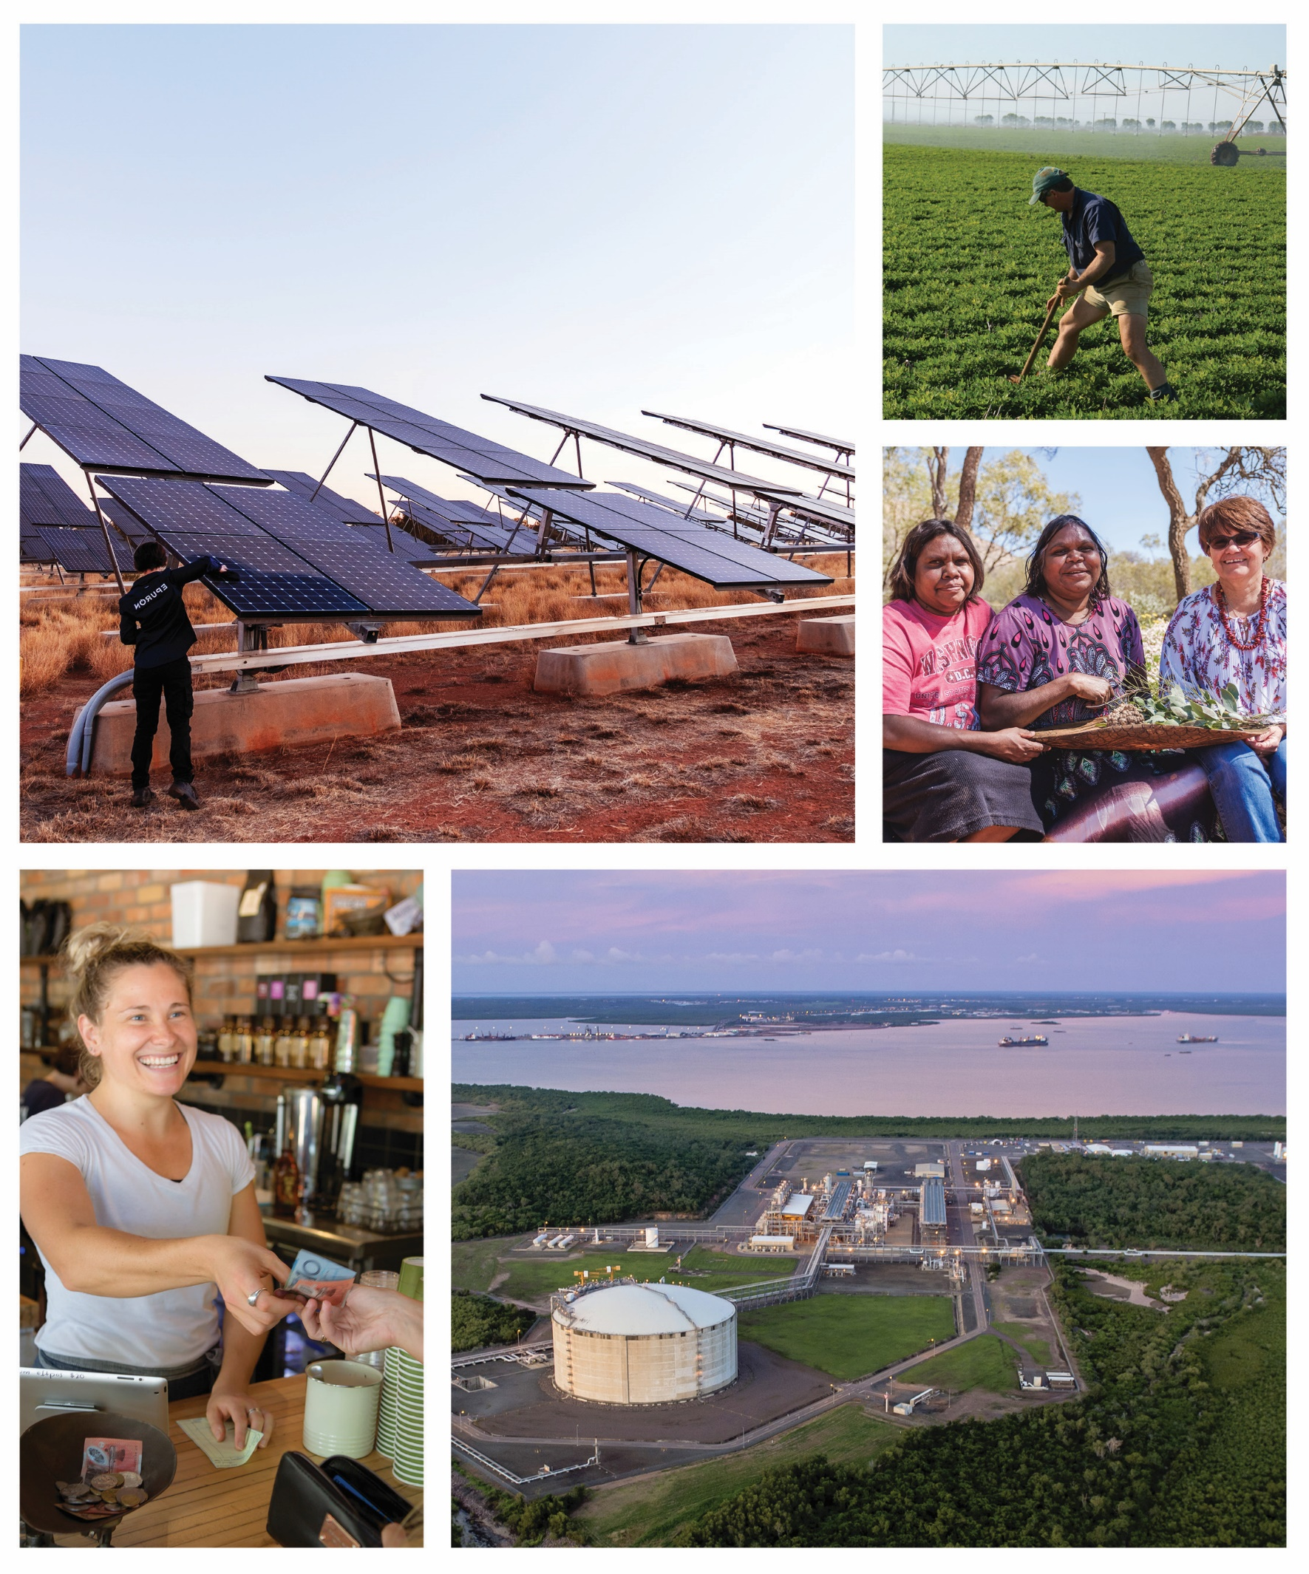
First Report – July 2020

Contents
Introduction 3
The challenge 3
The opportunity 3
The task right now 3
Economic growth in the medium term 4
Immediate jobs and investment 5
First Report Recommendations and Workstream areas 6
Energy (renewables and gas) 6
Renewables 6
Gas 7
Manufacturing (gas and non-gas) 7
Resources 8
Agribusiness 8
Water 9
Infrastructure 9
Roads 9
Tourism 10
Tourism Support 10
National Parks 10
Darwin Waterfront 11
Aboriginal Economic Leadership 11
Digital Industry 11
Regulatory and Administrative Reform 12
Other Workstream Areas 13
Logistics and Supply Chains 13
Workforce skills and population 13
Housing 13
Conclusion 13

Conflicts of Interest framework
An independent Conflict of Interest advisor has been engaged to oversee the conflict of interest framework during the operations of the Territory Economic Reconstruction Commission.
The members of the Territory Economic Reconstruction Commission have each signed a confidentiality and declaration of interests deed, and have registered and maintain a list of interests with the Secretariat Executive.

Introduction
The Territory Economic Reconstruction Commission’s responsibility is to provide advice on a path forward to grow the Territory economy in the medium term.
There is an urgency to the Commission’s work: COVID-19 has resulted in both Territorians and all Australians emerging from this crisis poorer than anyone could have anticipated.
Deloitte’s June 2020 Business Outlook describes COVID-19’s impact as taking ‘a sledgehammer to Australia’s economy, with no state or territory left unscathed’. The extent of this is being experienced in the Territory right now, with the substantial closure of the tourism industry, almost 20% of the Territory’s labour force currently on JobSeeker, and about a third of businesses accessing JobKeeper.
The Commission recognises the importance of the Territory and Australian governments’ emergency measures to support the economy, in particular the JobKeeper and JobSeeker programs. At the time of this report, the Commission understands the Australian Government is considering and rolling out a raft of measures to continue to support the economy. These measures will be critical for the Territory.

The challenge
For the Territory, this crisis has come at a time when the economy, having undergone a transition from a major construction boom, was just showing signs of turning around before COVID-19 delayed private and public sector funded projects.
While LNG exports have surged, the Territory’s economy had already shrunk 1.5% in 2018-19, from its peak of $26.5 billion in 2017-18. Further contraction is expected in coming months because of the crisis. This is significant and will affect every Territorian.

The opportunity
The pace and timing of economic recovery for the Territory is not certain, and will be reliant on the success of the recovery of Australia, as well as that of the Territory’s trading partners. Nevertheless, with focus and action, the Territory can build a strong path forward.
The foundations that underpinned the Territory’s growth over the past 20 years, from a $14 billion economy to a $26 billion economy, with a 25% increase in population and a 40% increase in the workforce, remain: world-class mineral deposits, including critical minerals necessary for modern life, access to water, a strategic location for defence, a quality solar resource spread across a wide area, a strong agricultural sector, highly prospective world scale onshore gas resources and proven offshore gas reserves, and proximity to markets in South East Asia.

The task right now
Economic recovery is on every state and every country’s agenda. To compete with economies that are rebuilding across the globe, the Territory must pursue a step-change in its approach to attracting business and private sector investment, or Territorian’s wealth, opportunity and lifestyle could fall behind.
For the Territory to compete and win investment, it needs to be the best place for business to start and grow. This will take more than a tag line, it will need a cultural shift towards greater agility and a focus on removing the disablers of private investment – the role of the private sector is crucial for the Territory’s economic growth.

The Commission’s initial focus has been on providing advice across two streams of work:
- what must happen now to position the Territory for future investment leading to jobs and economic growth in the medium term, and importantly,
- the actions, priorities and projects that deliver immediate jobs and investment across the next 12-18 months.
In providing this advice, the Commission has considered the contribution to GDP, value of enabling infrastructure for economic growth and job creation potential.

Economic growth in the medium term
The Territory Government has an ambition of creating a $40 billion economy by 2030. In the Commission’s opinion this is a significant ask and will require bold action against a program of work that prioritises the fundamentals.
To achieve this, the Commission is providing advice and recommendations in relation to:
- Significant growth across five main sectors: energy (renewables and gas), manufacturing (gas and non-gas), resources, agribusiness, and tourism, with a focus on attracting private investment, building the value-add and access to markets.
By quickly developing robust Masterplans that articulate jobs and GDP growth across industry areas and are marketable to Australian and international investors, the Territory can be ready to compete for investment.
- The enabling economic and social infrastructure, such as roads and water projects, to support growth in the key sectors.
- The supply of key industry inputs, such as stable and affordable power, and sustainable access to water for industry and community use.
Affordable and available power and water is an integral part of an overall commercial and sustainable strategy for growth.
- Engaging the Aboriginal estate in positive, Aboriginal led development.
Aboriginal Territorians own about 48% of the land and about 80% of the coastline, and hold native title over a significant proportion of the remainder. Territory economic growth must involve Aboriginal Territorians.
- Regulatory and administrative reform.
The Territory must become the easiest place in Australia to do business. This can only happen through smart regulation and administration that supports small business and reduces their costs.
- Increasing the capability of business, workforce and the public sector to meet the challenges and chase the opportunities – skilled, effective and innovative operators is what the Territory needs right now.
It can be tempting to announce support for particular industries or individual projects in isolation. But it is important that the economic fundamentals and the social and commercial drivers for industry and projects are well based in order to provide the Territory and Australian governments with confidence and clear evidence on how best to support, and to make trade-offs between initiatives, given the limited financial resources available.
Much like in other jurisdictions, the financing and funding of enabling infrastructure (roads, water, transmission lines, gas pipelines) is not solely the responsibility of the Territory or Australian governments. The Commission acknowledges that there is a crucial role for the private sector in relation to the delivery of key enabling infrastructure, especially where it relates to support for particular industries.

Immediate jobs and investment
While the Commission has a focus on pursuing the medium-term agenda, it also recognises that the Territory can start to rebuild off the back of the significant private sector led projects – located across the regions – that are close to making investment decisions. The focus should be on those projects that could start within the next three to 12-18 months.
There are several projects that can start soon if only the last remaining hurdles are addressed. In many cases this hurdle is financing – and with the options available, concerted joint focus over the next four weeks by senior representatives of the Territory and Australian governments, and the private sector proponents, could get these projects over the line.
Further, there is a solid pipeline of both Territory Government and Australian Government capital spending commitments, in particular in defence infrastructure. The Commission also notes the recent announcements by the Australian Government on investments to support Kakadu and Uluru-Kata Tjuta National Parks, and additional funding to support roads repairs and maintenance activity. The Territory should continue to work with the Australian Government, in collaboration with Traditional Owners, to ensure that existing government capital programs are maintained, wherever possible accelerated, and designed to deliver benefits locally.
The Commission also recognises the regulatory burden faced by small business. In an economic environment where small business is struggling, Government needs to reduce compliance costs and timeframes. The efficient administration of smart regulation is a key early focus of the Commission.

Table 1 - Immediate Projects
Project name | ~Value ($M)
Government led
Renewable Remote Solar Program (10 sites and planning for 23 more sites) | 36
Road access to six of the significant attractions in Kakadu National Park | 95
Central Arnhem Road | 420
Darwin Waterfront Expansion | 200
Private Sector led
Mining Projects | 1 500
Agribusiness Projects | 400

First Report Recommendations and Workstream areas
The Commission has identified key sectors and capabilities in forming the recommendations for the first report.

Energy (renewables and gas)
Energy as supplied by renewables and gas for domestic, industry and export use is one of the key underpinning requirements for economic growth in the Territory.

Renewables
The renewables sector is a fast-growing sector with considerable potential for further significant growth in the Territory. To achieve that potential requires investment in enabling infrastructure. Renewable energy has the potential to underpin industry growth, including in the emerging digital sector.
- To help understand the economics and opportunities of the renewable sector, the Commission recommends the Territory and Australian governments jointly undertake a study into an electricity highway based on high voltage direct current (HVDC) transmission links between Darwin and Alice Springs. The scope of this study should consider the potential for a design that enables multiple projects that both supply and make use of renewable electricity up and down the spine of the Northern Territory, potentially supporting the creation of renewable energy zones. The study should also assess the potential for a link from the Territory to the National Electricity Grid to facilitate the connection of large-scale renewables generation that would supply east coast power demand.
The Commission also considered several projects in the Government project pipeline, and supports the work underway on the following projects:
- The Darwin to Katherine Electricity Network and Darwin Battery Energy Storage System (BESS) project to deliver critical power system needs and regulatory and market reforms to support greater levels of renewables generation connecting to the electricity grid, while maintaining acceptable system security and reliability. The Commission is interested in options to accelerate this work, in particular how to address system reliability concerns. The Commission also notes the potential requirement for financial support for the large-scale BESS.
- Install solar photovoltaic and battery energy storage setups across ten remote communities under the Renewable Remote Power Program, concurrently with site planning for the next 13 sites ($36 million first ten). The Commission notes the benefits of diesel displacement, and therefore the reduction of greenhouse emissions, the reduced government subsidies required for the cost of supplying power, and the job creation benefits.

Gas
The Beetaloo Sub-basin shows significant potential to provide gas and liquids for energy use and to underpin a petrochemical manufacturing industry in the Territory – driving significant economic benefit. This potential benefit is nationally recognised but requires additional appraisal to further define the resource and potential development pathways.
The Commission notes the work underway in relation to the assessment of and planning for infrastructure to service the potential development of the Beetaloo Sub-basin.
- The Commission recommends that the Territory Government, in conjunction with the Australian Government, accelerates the preliminary design and development assessments for critical enabling infrastructure to support development of the Beetaloo Sub-basin in the event commercial feasibility is proven.

Manufacturing (gas and non-gas)
The Territory’s Middle Arm Industrial Precinct provides the opportunity for the significant growth of private sector led manufacturing in the Territory in a range of industries and downstream sectors.
Opportunities include development of renewables driven manufacturing such as hydrogen, the production of ammonia, and minerals-processing. Opportunities also include the manufacturing of petrochemicals, initially using gas from offshore sources, then gas and liquids from the Beetaloo Sub-basin.
- In recognition of this opportunity and considering what is missing from existing feasibility studies and planning, the Commission recommends the Territory Government urgently undertakes the following Masterplan activities that can be used to attract relevant private sector enterprises, including to the Middle Arm Industrial Precinct:
  - Renewables based hydrogen industry – with high solar irradiance spread across large areas of land the Territory can produce renewable energy at scale and there is significant opportunity to position the Territory at the forefront of the developing renewable hydrogen industry.
  - Minerals processing – with some of Australia’s largest mineral deposits, there is significant opportunity to grow on and off-site mineral processing and value adding opportunities, including for the manufacture of components and products.
  - Low emissions fully integrated petrochemical industry – with the Territory’s availability of gas and liquids (providing the molecules for the petrochemical manufacturing industry), there is significant opportunity to grow this industry and all downstream sectors like packaging, consumer products, building materials, plastics processing, and pipes and cables. There are many other sectors that could be attracted downstream from a full scale petrochemicals complex, in a variety of industrial clusters.
The Masterplans must be completed quickly, articulate both jobs and GSP growth, and be marketable to Australian and international investors.

Resources
The Territory has a world-class resource endowment with some of Australia’s largest mineral deposits in non-ferrous metals (zinc, copper, lead tungsten), battery and high-technology minerals (lithium, rare earths and vanadium), fertiliser commodities (phosphate and potash), gold and uranium. The Commission looks forward to further understanding the opportunities, complexities and issues facing the resources sector in the Territory as its work progresses.
The Commission also notes advice from the private sector in relation to mining projects that are close to starting work in the short-term, if only financing gaps can be bridged.
Based on the information provided, these projects have significant capital investment of close to $1.5 billion and during operations could collectively contribute more than $500 million a year to the economy and over 400 ongoing jobs into the community, mostly benefiting regional areas. Proponents of these projects have also committed to the development of an Aboriginal workforce and contracting with Aboriginal businesses.
- The Commission recommends the Territory and Australian Government jointly consider and assess what financing options would be required to move mining projects that are close to final investment decision over the line.
  - To achieve the above, as well as other projects discussed below, it is recommended that the Territory and Australian governments agree to urgently establish an Investment Delivery Taskforce which, over the next four weeks (ready for the incoming government), would identify options to accelerate project investment decisions in projects that (a) have secured or are anticipated to be able to secure key approvals, and (b) having secured key approvals, can start construction within the next 12-18 months.
  - The Taskforce would engage with Australian and Territory government financing facilities set up to support development in northern Australian and Australian export opportunities to identify what is required to unlock funding.
  - It is recommended the Taskforce comprises one member from each government and the co-chairs of the Territory Economic Reconstruction Committee.
The Commission recognises that the Territory Government is not in a position to bridge financing gaps on its own and that solutions require joint effort by governments and the private sector.

Agribusiness
Agribusiness currently directly contributes 2.6% GSP to the Territory economy. The Territory’s natural advantages and greenfield sites provide significant opportunity for growth when the settings are right.
The Commission will further explore the opportunities and requirements for the growth of this sector, and notes the Territory Government’s work in relation to agricultural precincts, which it will consider further, and the Katherine Agribusiness and Logistics Hub, which will support agribusiness and resources projects in the region get to markets sooner. The Commission also notes there are several specific projects where preparation is well underway, including in aquaculture and broad acre cropping.
- Similar to the approach for mining projects above, the Commission recommends the Investment Delivery Taskforce consider options to accelerate agribusiness projects close to final investment decision.

Water
A key enabler for agribusiness and other industry growth is the availability of sustainable water. Current water used in the Territory is mainly sourced from ground water, unlike other areas of Australia. Wet season rainfall in the Top End of the Territory is seen as an opportunity that could be a key advantage if effectively captured to support industry and population growth.
Establishing water infrastructure is expensive and comes at a significant cost to the taxpayer if water demand is not efficiently managed. Opportunities to address and manage current demand, (Territorians domestically use significantly more water than other states) as well as staged development of new water infrastructure, should be pursued.
- As a key piece of infrastructure to meet future demand for water supply in the greater Darwin Region, the Commission recommends the detailed business case development and economic options assessment of new water supply infrastructure in the Greater Darwin region (e.g. Manton Dam Return to Service and Adelaide River Off-stream Water Storage) is accelerated by concurrently undertaking preparatory works, and that the options analysis also integrates demand management and efficiency options.

Infrastructure
Infrastructure can help catalyse growth across the Territory and unlock development across a range of industries. It is also of considerable interest across the Territory, with many of the public submissions received to date by the Commission addressing infrastructure projects, issues and opportunities. There are several projects in this report that are either enabling infrastructure, or require infrastructure works to proceed. Available funding is a key constraint. The Commission will continue to consider these matters over the coming months.

Roads
Quality road infrastructure is the backbone of economic development across a region. Roads are also expensive to build, and the Territory’s vast distances provide a challenge for achieving the right balance between cost and access.
As part of its initial deliberations, the Commission recognised the significant benefit of the Central Arnhem Road project for regional, industry and community access.
- The Commission recommends the Territory Government approaches the Australian Government to bring forward nominally committed road funding on the basis that the Territory Government will accelerate the upgrade of the Central Arnhem Road from Katherine to Nhulunbuy to a two-lane sealed standard to provide year-round access, and in doing so support the fulfilment of the East Arnhem region’s potential for economic development, including an Aboriginal led tourism industry (an additional $420 million on top of the $230 million over 10-15 years currently committed).
This will require the Territory Government to quickly pull together an experienced program team, with road development, community consultation, and strategic procurement expertise to accelerate the work by getting packages of work out the door quickly (potentially this dry season), and enable Aboriginal enterprise and workforce involvement as a key requirement of the project.
The Commission also recognises the potential value of the Tanami Road, with its gradual sealing funded by the Australian Government under the National Partnership Agreement on Land Transport, and would like to further explore up to date market information in relation to the road and its relative economic benefit to the Territory and the Central Australia region.

Tourism
Pre COVID-19, tourism comprised 4.2% of the Territory economy and about $2.6 billion from the visitor economy circulated out through small business. The Commission recognises how the current crisis has affected the tourism industry, both locally and nationally.

Tourism Support
The seasonality of the tourism season across northern Australia, being confined largely to the middle months of the dry season, is always a significant challenge for small tourism operators. In the current environment there is a real threat some will not survive the next 12 months.
- The Commission recommends the Territory Government works with the Queensland and Western Australia governments to advocate for targeted financial support for tourism across northern Australia, including to ensure operator survival until the 2021 tourism season.

National Parks
The broader parks estate in the Territory is an obvious key advantage for Tourism. Most of the Territory’s parks estate is jointly managed with Traditional Owners, and Traditional Owner involvement in the development of the estate is fundamental to any development.
Australian Government Parks: The Territory has two of Australia’s iconic tourism destinations, Kakadu and Uluru-Kata Tjuta National Parks, which are the responsibility of the Australian Government. Developing these destinations becomes important not only for the Territory’s tourism recovery, but also Australia’s tourism recovery.
The Commission notes the work underway to build the infrastructure for Kakadu and the township of Jabiru, with significant commitments made by both the Australian and Territory governments. Nevertheless, access to Kakadu’s attractions underpins its recovery as a tourist destination and is foundational for private sector investment to flow.
- The Commission recommends the Territory Government engages with the Australian Government and the Kakadu Board of Management in regard to the pursuit of an additional $95 million of roads funding to fully fund the work to open and expand access to six of the significant attractions in Kakadu, with an acceleration of this work for completion from the currently planned 10 years to the next two years to take advantage of the reopening of international tourism.
Working together, the Territory Government, the Australian Government, and the Traditional Owners, can plan for and undertake this development, concurrently with other works, to ensure the park can meet its tourism potential as part of a global Australian tourism push.
The Commission also notes the Territory Government’s ongoing discussions with the Australian Government on additional near-term investment opportunities in both Kakadu and Uluru-Kata Tjuta National Parks including and following recent announcements, and the important role of Traditional Owners in these discussions.
Territory Government Parks: The Commission recognises the significant investment the Territory Government is making to open additional attractions across the Territory parks estate. This includes investment in Litchfield, Nitmiluk and around Alice Springs.
With additional investment comes the opportunity to leverage private investment in new accommodation and other offerings. The Commission will consider this further through its work program.

Darwin Waterfront
The Commission also notes the Territory Government’s vision for the Darwin Waterfront expansion, and the potential for this staged integrated development to underpin both liveability to support population retention and growth, and its potential as a domestic tourism destination that makes the best of Darwin’s tropical location.
- Noting the land the Territory Government is making available to underpin the project and the strong potential for private sector investment, the Commission supports the Territory Government discussing the Darwin Waterfront Expansion as part of the City Deal program and pursuing private sector funding for the expansion.

Aboriginal Economic Leadership
Aboriginal Territorians are leaders in the Territory’s economic future.
About 48% of the land and about 80% of the coastline is owned by Aboriginal Territorians under the Aboriginal Land Rights (Northern Territory) Act 1976 (Cth). A significant proportion of the remaining land and waters are, or are likely to be, subject to native title.
There are about 75,000 Aboriginal people living in the Territory, 80% of whom live in remote or very remote areas. Aboriginal Territorians represent 30.3% of the total population of the Territory.
The Commission acknowledges, recognises and respects the rights and land ownership of Traditional Owners in the Territory and looks forward to further understanding how best it can support Traditional Owners, native title holders and other Aboriginal Territorians to lead, partner and participate in the economic development of the Territory.
- In considering its initial recommendations in this report around immediate projects, the Commission strongly recommends that all projects, and particularly those in remote and regional areas, are designed to involve local Aboriginal workforces and enterprises.

Digital Industry
The Commission notes the work currently underway to support the growth of the digital industry in the Territory, including the Terabit Territory project, and the opportunities for datacentres. It also notes the heavy energy requirements of datacentres, leading to opportunities to increase energy demand and support growth and opportunity in the energy sector. The growth of the digital industry should lead to significant opportunity for local businesses.
- The Commission supports the Territory Government, working with the Australian Government, engaging with industry participants to identify financing options that will accelerate additional investment in international subsea cable connectivity into Darwin from Asia and the USA, including to facilitate investment in datacentres.

Regulatory and Administrative Reform
While regulation is important to protect the Territory community and public resources, the way regulation is administered can either help or hinder business activity and the economic growth that comes with it.
The Commission recognises that private sector feedback over a long period of time has identified that the administration of regulation in the Territory is a problem. It also recognises the political will to improve this issue.
To become the easiest place in Australia to do business, the Territory public service must step up. This will require a singular focus on outcomes, and the will to look at structures, invest in digital solutions and develop its culture to one of efficiency, effectiveness, and agility.
- The Commission recommends the Territory Government urgently pursues the following:
  - A target of having the most efficient approval processes in Australia for all Territory business licensing and approvals to start and grow a business, with an initial focus on 30-day maximum approval timeframes for retail, hospitality and construction for straightforward applications.
    - To progress this, it is recommended the Territory Government requires Chief Executive Officers of relevant agencies to provide a consolidated options paper to the Commission by end August 2020 on how these outcomes could be delivered. The options paper should identify existing licensing and approval timeframes, and what is required to achieve the target timeframes and outcomes by 30 June 2021, including stepped progress towards the same.
  - A single regulatory door into government for all projects, which includes a time-limited function of a Major Project Coordinator to get things moving quickly. To progress this, it is recommended the Territory Government:
    - establishes a system of ‘First Pass’ approvals that provides certainty for proponents that their project is supported, subject to them meeting the full suite of regulatory requirements
    - focuses on how to halve the timeframes for project approvals, and requires the Jobs Standing Committee of the Chief Executive Officers Coordination Committee to provide advice to the Commission by end August 2020 on how the above can be achieved.
The Commission notes that other jurisdictions, like the private sector dealing with similar issues, have worked side-by-side with expert consultants to help work through the operational changes required.

Other Workstream Areas
In addition to the above, the forward work program of the Commission includes the following areas:

Logistics and Supply Chains
The Commission recognises that the success of any business depends on the costs and speed of access to markets for inputs and outputs. Costs and availability of shipping, rail, air and road are all significant factors for production (inputs) and export.
Access to market is expensive in the Territory. The Commission will consider this issue as its work program progresses.

Workforce skills and population
The Commission recognises the critical importance of workforce skills and population as key enablers supporting economic growth.
The Commission notes the current challenges that international border closures are having on migration, which has been the Territory’s largest source of population growth.
The Commission will consider opportunities in the area of International education, including in the Vocational Education and Training (VET) sector, and is also interested in exploring the development of educational pathways to skills attainment, focused on sectors identified within the Commission work plan, to help meet the future workforce needs of the Territory.

Housing
The Commission is interested in exploring current issues regarding the sustainability of the remote housing system, as well as urban housing issues across the Territory.

Conclusion
As outlined in this report, the Commission has developed a work plan focused on the key sectors and capabilities it considers to be the most critical in the current environment for the Territory’s medium-term growth.
Over the next five months, the Commission will continue to discuss and consider issues as they emerge, taking the advice of Team Territory, Regional Reconstruction committees, Land Councils, peak industry organisations, Territory businesses and the general public.
The evidence-based insights from Territorians through the submission process will inform how the Commission’s priorities and advice evolves towards the final report in November.

